Technical description of the lock-in amplifier LIHV200 (#120512)

The lock-in amplifier LIHV200 is designed to lock the frequency of a tunable laser to an appropriate reference (a resonance of media absorption, a resonance of an optical cavity or a Doppler-free resonance). It consists of a power supply, a built-in generator, a phase shifter, an analog multiplier and a PID–regulator with adjustable time constants. In addition, the LIHV200 has a high-voltage amplifier and a triangular-wave oscillator to control piezo-elements. The block-diagram (Fig.1) reflects the destination and interaction of the components. The principle of the lock-in operation is based on the fact that the product of two sinusoidal signals of the same frequency depends on their relative phase difference:

.
Since the detected signal of modulation changes the sign at the extreme, it becomes possible to register the change. The high-frequency term of the indicated expression can be filtered then to get derivative-like signal for laser frequency stabilization.

Fig.1. The block-diagram of LIHV200. 1- sine-wave generator; 2- phase shifter; 3- input amplifier; 4- high-pass filter; 5- low-pass filter; 6- multiplier; 7- proportional amplifier; 8- integral amplifier; 9- differential amplifier; 10- sum amplifier; 11- high-voltage amplifier

Fig.2 shows the front and rear panels of the LIHV200. The front panel of the LIHV200 is segmented on a few functional zones whose meaning is cleared up below. Further explanation of the LIHV200 operation will refer also to the electronic circuits (Figures 3 – 9) and the layout (Fig.10).
An analog power supply (Fig.3) provides all voltages essential for the proper operation of the device: +15V, –15V, and +140V. There are three fuse sockets under the unit lid close to the line connector. One socket corresponds to the line voltage of 240V AC, another one – to the voltage of 220V AC and third one – to 117V AC. Only one fuse of 0.5A must be inserted into the relevant socket! One more fuse of 160 mA (F1 from Fig. 3) protects the output of the high-voltage power supply from the abridgement.

Fig.2. The front and rear panels of LIHV200

The built-in generator (position 1 of Fig.1 and U6 on Fig.4) produces sine wave of about 10 kHz. The phase shifter (pos.2 of Fig.1 and VT2 on Fig.4) converts this signal into two signals whose relative phase can be changed in the range of 320°. One of these signals (i.e. reference – U4, U5, and U3 on Fig.4) is directly coupled to an analog multiplier (pos.6 of Fig.1 and U15 on

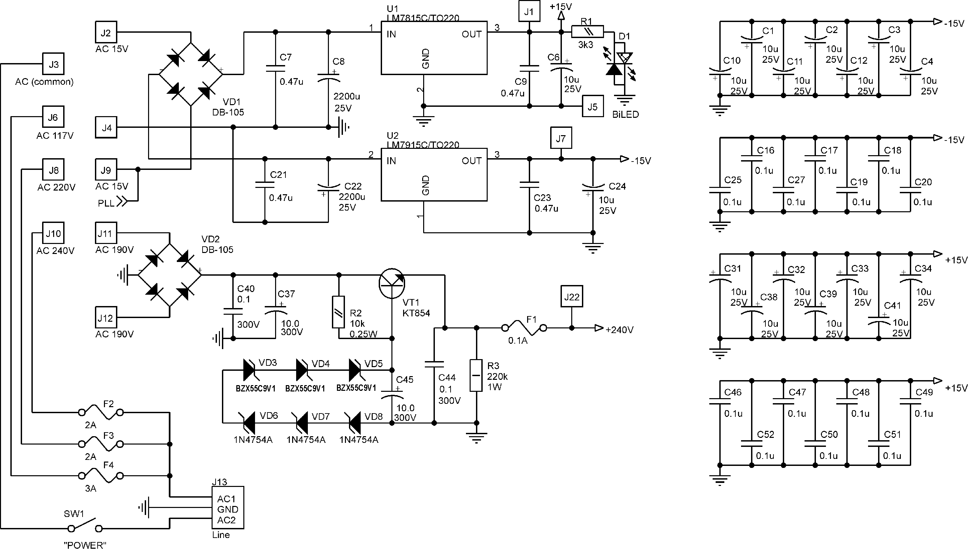

Fig.3. The circuit of the power supply
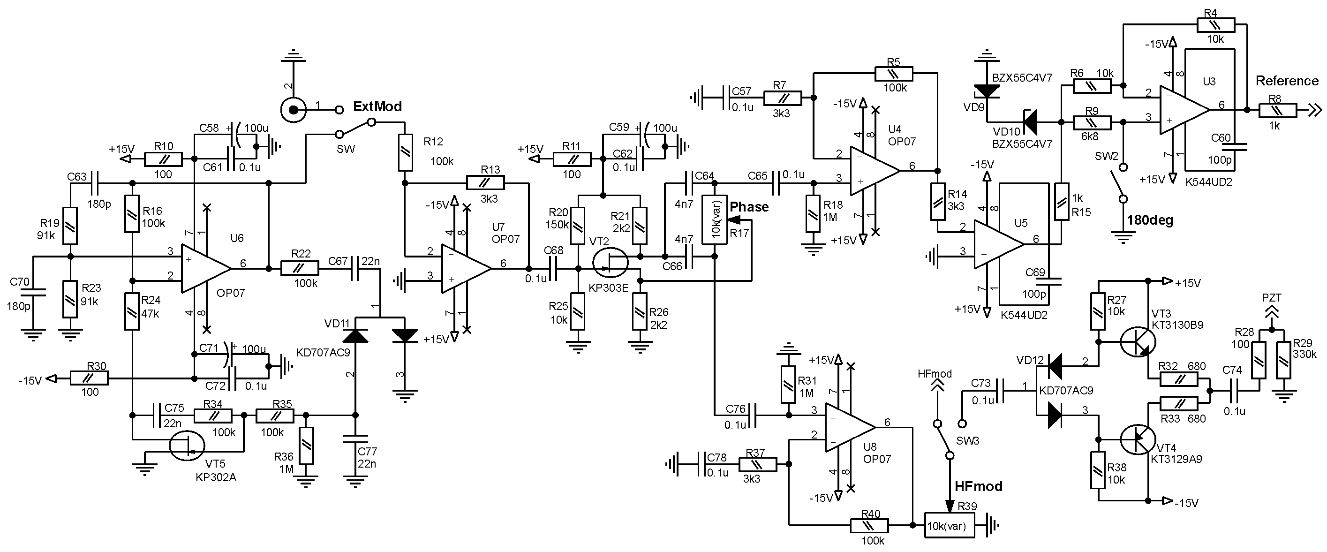

Fig.4. The circuit of the sine-wave oscillator, the phase shifter, and the power amplifier

Fig.5), and another one (i.e. modulation, U8 on Fig.4) is used to modulate the frequency of a laser or of an optical resonance. The regulator of the modulation amplitude (R39 on Fig.4) and the output of modulation (BNC-connector) are located in the MODULATION zone of the LIHV200. The maximum amplitude of modulation at the output is about 3V_{p-p}. By default the signal of modulation is coupled also to the input of a high-voltage amplifier (HVA – pos.11 of

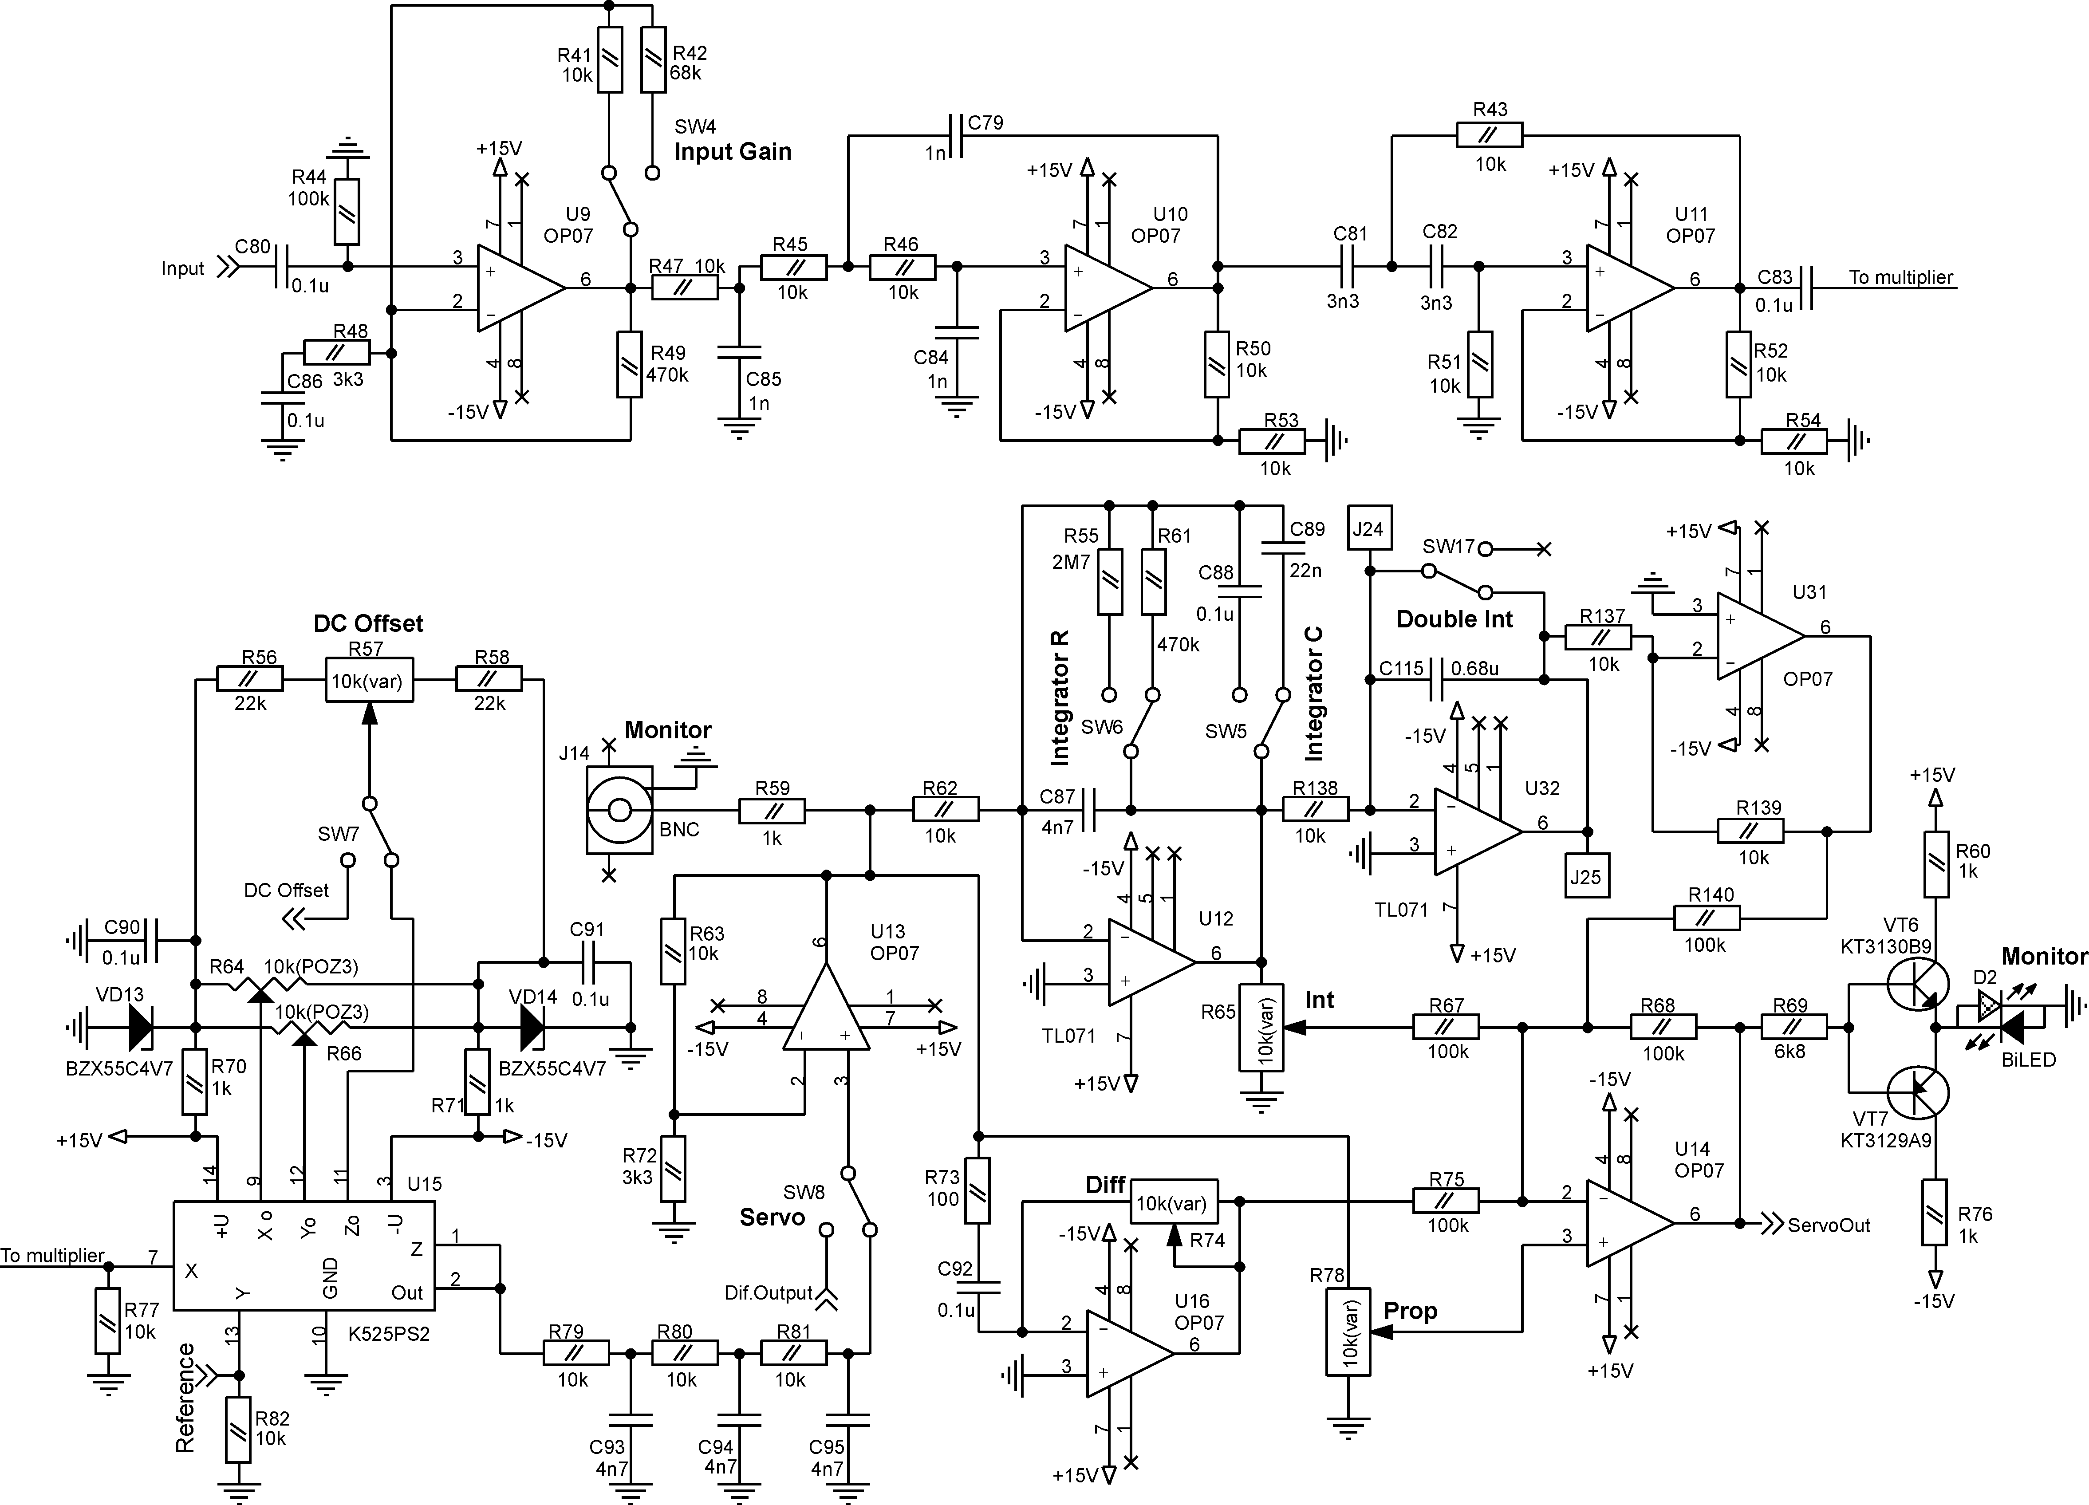

Fig.5. The circuit of the input amplifier, the low-pass and high-pass filters, the multiplier, and the PID-regulator
Fig.1 and the circuit on Fig.9), that allows controlling piezo-elements (PZT) of a laser or a reference cavity. The modulation signal can be redirected from the HVA to a power amplifier (VT3, VT4 on Fig.4) or can be completely disconnected from the both of them by the jumper on the circuit board of the lock-in amplifier (SW3 on Fig.4 and Fig.10). The jumper SW3 is accessible when the upper lid of the LIHV200 is open.

Fig.6. The circuits of the photo amplifier with the output connector DRB-9F and of the differential amplifier (not presented in LIHV200)

The HV amplifier has relatively high output impedance (about 10⁴ Ohms). So the power amplifier should be preferably used for high frequency modulation of a piezoelement with the capacitance above 100 nF. The output of the power amplifier is connected to the pin 7 of DRB-9F connector (J17 on Fig.6), which is positioned on the rear panel of the LIHV200. The pins 8 and 9 of J17 are the outputs of the high-voltage amplifier. The high-voltage amplifier is paraphase, that actually doubles the output amplitude by reversing the voltage phase at the ends of the load. Only one half of the HV amplifier has to be used with the unipolar piezoelements. Then the pin 8 (or 9) of DRB-9F must be connected to the positive end of the piezoelement, and its negative end should be grounded (pins 2, 4 or 6). Fig.7 shows how unipolar high capacitance piezoelement might be connected to J17.
The LIHV200 can operate under conditions of external modulation. In that case the input of the phase shifter (U7 on Fig.4) must be switched over (jumper SW on Fig.1 and Fig.4) between the output of the built-in generator and the input of an external signal (the BNC connector ExtMod on the rear panel). The ExtMod switch is located on the circuit board of the LIHV200 (Fig.10).
The optically detected signal is amplified (pos.3 of Fig.1 and U9 on Fig.5) with three possible levels of the gain (L – low, H – high, M – medium). The input BNC-connector (J16) and the gain switch (SW4) are in the INPUT zone of the front panel. The medium gain corresponds to the input signal of about 50 mV_{p-p}. L-position of the switch tenfold reduces the gain; H-position tenfold increases it. The amplified signal is then filtered to minimize the influence of low-frequency noise and quadratic component in the detected signal, since the detected 2f-component shifts the zero level of the lock-in output. The high-pass and low-pass filters (pos.4, 5 of Fig.1 and U10, U11 on Fig.5) are preset according the modulation frequency, and they have corner frequencies at 5 kHz and 15 kHz respectively.

Fig.7. Connection of a high capacitance piezoelement to the LIHV200

The relative phase of the input and reference signals can be adjusted gradually with the potentiometer or step changed by the switch (R17 and SW2 on Fig.4) which are located in the PHASE zone.
An analog multiplier (pos.6 of Fig.1 and U15 on Fig.5) gives at the output the voltage proportional to the product of the detected and reference signals. The product contains the 2f-component (see the expression on the page 1), which is filtered then (R79-81, C93-95 on Fig.5) to get the derivative-like signal. The BNC-connector MONITOR in the OUTPUT zone of the LIHV200 enables observing the filtered output of the multiplier. The trimmer ZERO in the same zone changes DC level at the multiplier output (R57 on Fig.5). This gives possibility to shift locking point in respect to the extreme of an optical resonance.
To get reliable and stable frequency lock the gain in the feedback loop must be precisely set according to the frequency response of the controllable object (a mirror attached to a piezo-mount, laser current, galvano-drive, etc.). This task is solved using PID-regulator, which has three parallel arms with different transfer functions. The output of the proportional amplifier (pos.7 of Fig.1 and U13 on Fig.5) is frequency independent. The gain of the integral amplifier (pos.8 of Fig.1 and U12 on Fig.5) reaches the maximum at very low frequencies and tends to zero at high frequencies. The differential amplifier (pos.9 of Fig.1 and U16 on Fig.5) has inverse in respect to the integral one frequency behavior. The gain (or the corner frequency) of each arm can be set independently, and the overall gain is the sum of them (pos.10 of Fig.1 and U14 on Fig.5).
The time constant of the integrator is step changed with the switch C in the INTEGRATOR zone. The feedback capacitance (Ci on Fig.1 and C87-89 on Fig.5) equals 4.7 nF at the L-position of the switch (low capacitance), 22 nF at the M-position (medium), and 100 nF at the H-position (high). The shunt resistor (Ri on Fig1 and R55, R61 on Fig.5) limits the integrator gain at very low frequencies to prevent the gain saturation and to facilitate the capacitance discharge. The switch R in the INTEGRATOR zone sets three available values of the shunt resistor: L – 470 kOhm, M – 2.7 MOhm, and H – no resistor at all.
The trimmers P (R78 on Fig 5.) and D (Rd on Fig.1 and R74 on Fig.5) in the GAIN zone set the gain of the proportional amplifier and the time constant of the differentiator respectively. The output of the sum amplifier is coupled to the right BNC-connector in the OUTPUT zone, and the dichromatic light emitting diode MONITOR located in the same zone displays the voltage level at the output of the sum amplifier. It lights red if the voltage is above 2V, and it lights green if the voltage is below –2V. Thus, at the in-lock condition the absence of light evidences the stable lock, while the light appearance indicates that the system tends to go out of lock.

Fig.8. The circuit of the triangular-wave generator

The LIHV200 is supplemented with a triangular-wave oscillator (Fig.8) and a high-voltage amplifier (HVA, pos.11 of Fig.1 and Fig.9). The internal ramp can modulate the output of the HVA at the line frequency and its sub-harmonics f, f/2, f/4, f/8. To set the ramp frequency only one corresponding jumper of the DIP-8 switch (SW14 on Fig.8) must be set in position ON. The switch is located on the circuit board (Fig.10). The frequency f/2 (that is 30 Hz for USA and 25 Hz for Europe) is pre-set in LIHV200. The triangular signal of about 3V_{p-p} from the TRIG output can be used to control or to synchronize external devices.
In order to control the output of the high-voltage amplifier by an external signal, the EXT-INT switch must be set into the EXT position and the external signal must be connected to the BNC-connector IN. In this case the internal ramp is disabled and the TRIG output reduplicates the external signal.

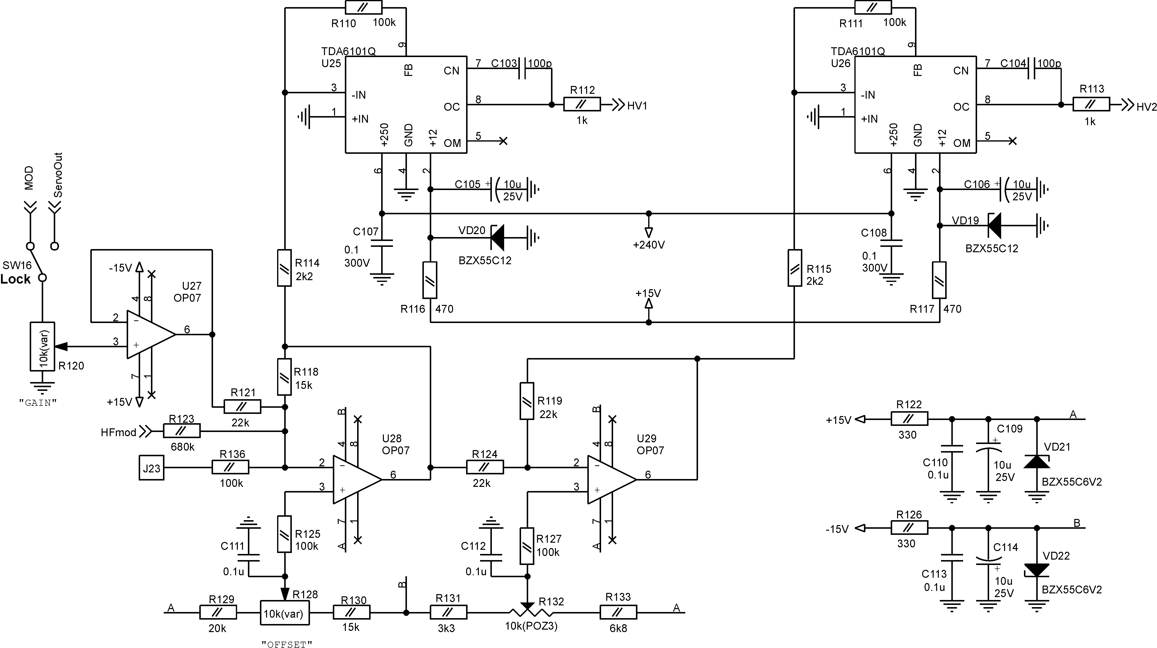

Fig.9. The circuit of a high-voltage amplifier

The control knobs of the HVA are located in the PZT zone of the front panel (Fig.2). The left one (SWEEP) regulates the amplitude of AC component at the HVA output, and the right one (LOCK) sets the DC level of the high-voltage output. The toggle switch above the knobs (SWEEP-LOCK) switches over the input of the HVA between the ramp signal (SWEEP) and the output of the lock-in PID-regulator (LOCK). Thus, the SWEEP knob changes the ramp amplitude if the switch lever is in SWEEP position, and it controls the overall gain of the closed feedback loop if the lever is in LOCK position. The DC level of the HVA output is set regardless of the switch lever position.
The dimensions of the LIHV200 are 240x165x40 mm³, the weight – 1.2 kg.

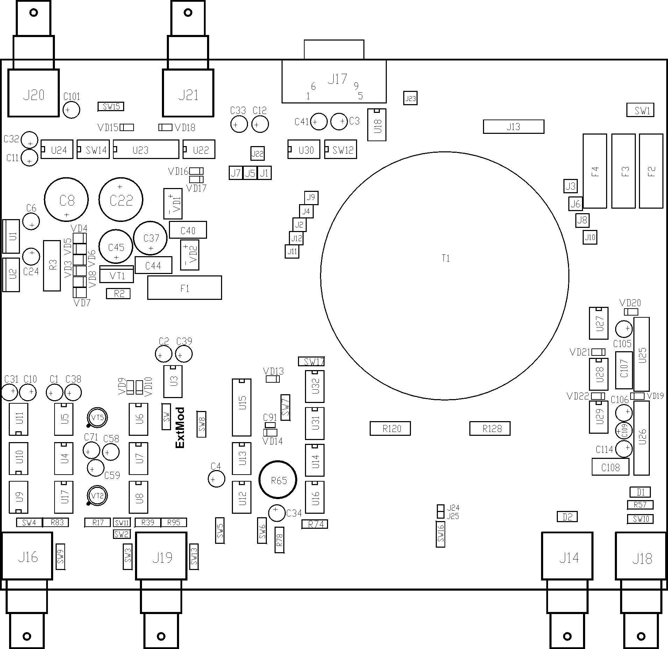

Fig.10. The layout of the lock-in amplifier

How to lock a laser?
To lock a laser to an appropriate frequency reference, follow the next sequence of operations:
1. Check the initial position of all control switches and trimmers:
INPUT switch – M (medium input gain),
MODULATION trimmer – extreme left (counter clockwise),
PHASE switch and trimmer – no matter,
INTEGRATOR R switch – M (medium value),
C switch – M (medium value),

GAIN P trimmer – extreme left (counter clockwise),
D trimmer – extreme left (counter clockwise),
PZT switch – SWEEP,
SWEEP knob – midposition,
LOCK knob – midposition,
ZERO – midposition.
2. Tune the laser frequency in such a way that the reference resonance to be used for locking is in the center of the sweep range.
3. Reduce the ramp amplitude to observe only required resonance, and all other potential references should remain outside of the sweep range.
4. Increase the modulation amplitude (turn the MODULATION trimmer clockwise) to get the dispersion-like signal of about 50 mV_{p-p} from the MONITOR connector in the OUTPUT zone. Optimize the shape of the signal with the PHASE trimmer. The optimized output signal has the maximum span.
5. Adjust to zero the medium point of the dispersion-like signal using the OFFSET trimmer (the input of a test oscilloscope must be DC coupled). This coincides with the locking to extreme of the reference resonance.
6. Turn the switch from the PZT zone to the LOCK position. The level of the optical signal has to be pulled to the extreme of the reference resonance. If the laser frequency moves away of the resonance, switch over the 0-180 switch in the PHASE zone.
7. Set the R-switch from the INTEGRATOR zone to H-position.
8. Turn clockwise the control knob SWEEP unless the stable oscillations at the MONITOR output appear.
9. Turn clockwise the trimmer D (GAIN zone) to suppress the oscillations and then the trimmer P to minimize the amplitude of the error signal.

To relock an unlocked laser it is enough to restore initial positions of all control elements from the PZT zone and then repeat entries 2, 3, 6, 8 from the above-mentioned sequence of operations.

